# Job-Driven Vocational Rehabilitation Technical Assistance Center

# (JD-VRTAC)

The JD-VRTAC helps build the capacity of vocational rehabilitation (VR) agencies to expand job-driven employment practices for consumers. We strive to identify, adapt, embed, and sustain job-driven practices for VR agencies and their partners to provide services that lead to employment outcomes for people with disabilities by:

* Creating VR-specific, sustainable models of job-driven practices
* Promoting the use of labor market information in the counseling process
* Helping businesses find and retain qualified workers
* Using and building upon promising and emerging job-driven strategies
* Providing technical assistance (TA) to state VR agencies (see details below)
* Disseminating toolkits and materials about job-driven strategies

**Technical Assistance (TA)**

The JD-VRTAC provides **universal**, **targeted**, and **intensive** TA to state VR agencies on ways to engage and support employers and customized training providers, as well as how to understand and incorporate labor market information into VR practice.

* **Universal TA:** The JD-VRTAC uses ExploreVR.org as the primary portal for providing universal TA via a set of job-driven toolkits. All universal TA resources are targeted towards the three organizational levels: leadership, field services, and counselors.
* **Targeted TA:** The JD-VRTAC provides targeted TA through communities of practice and in-person forums. The topics for these peer-to-peer groups were identified from a nationwide needs assessment survey, issues emerging from intensive TA, and feedback from VR agencies.
* **Intensive TA:** Agencies receiving intensive TA were assigned a team of content experts to guide the development and implementation of their job-driven project. Intensive TA agencies have joined a learning collaborative to share strategies and solutions around these job-driven topics.

**Project partners**

* Jobs for the Future
* University of Arkansas CURRENTS
* University of Washington
* US Business Leadership Network
* Council of State Administrators of Vocational Rehabilitation
* Association of University Centers on Disabilities

**In collaboration with**

* National Council of State Agencies for the Blind
* Technical Assistance Center Collaborative

**Job-Driven Toolkits**

The JD-VRTAC has developed tools and resources to improve skills of VR agency staff and other rehabilitation professionals who provide job-driven VR services and supports to people with disabilities, employers, and customized training providers.

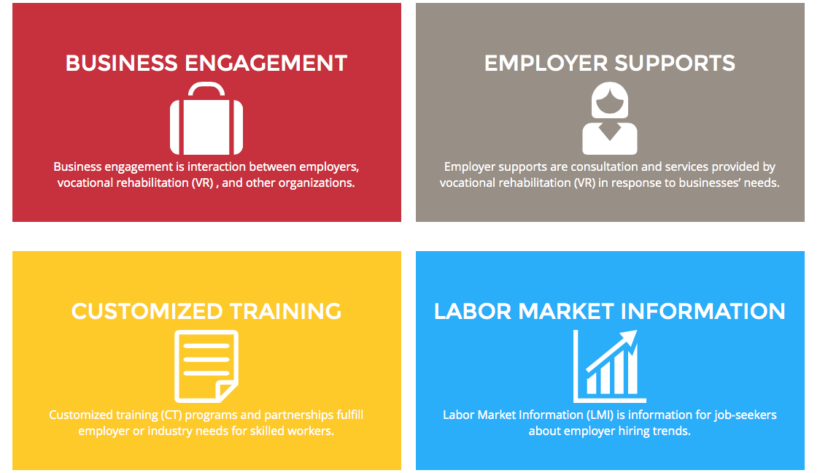

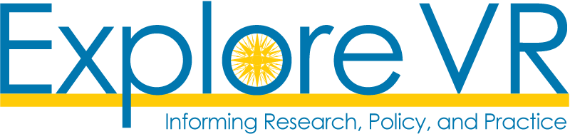

*The Job-Driven VRTAC is funded by Rehabilitation Services Administration Grant (RSA) #H264A140002.*